BIT 4107 – Mobile Application Development
LOGBOOK

Student Name: Mopeyian Felister
Admission Number: BIT/2025/69147
School/Faculty: Computing and Informatics
Programme: Bachelor of Science Information Technology (BSCIT)
Academic Year: 2025/2026
Semester: THREE
Lecturer: MR. MICHAEL NYORO
Phone Number:

Week 1: Introduction to Mobile Application Development

1.1: Practical Activities Undertaken (SCREENSHOTS)
1. Installation of Android studio
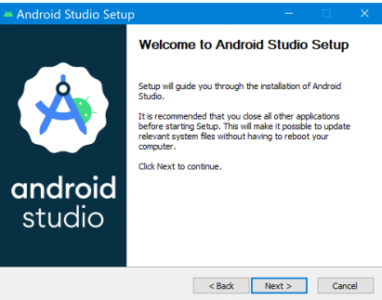

Installation of Flutter and Dart Extension in Android
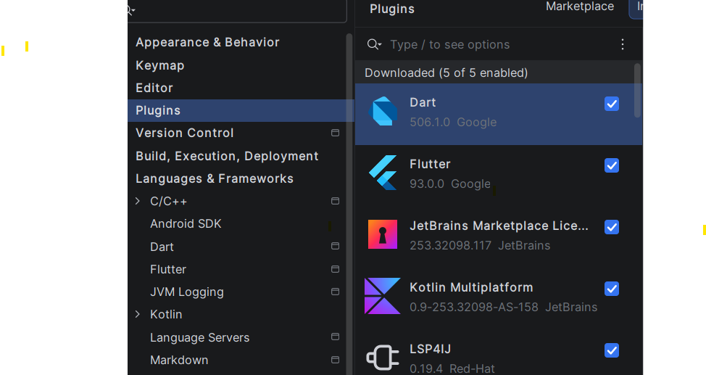

3.Hello World screenshot
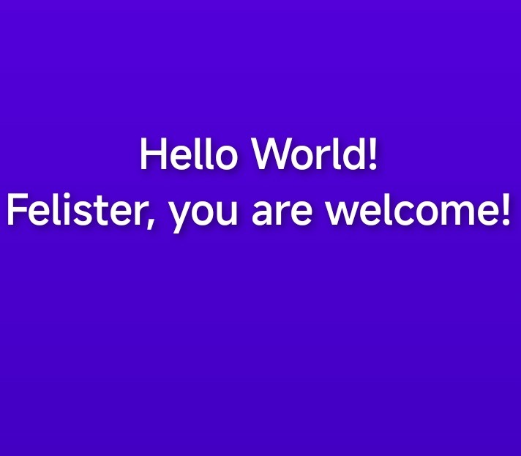

4 Hello world source code.
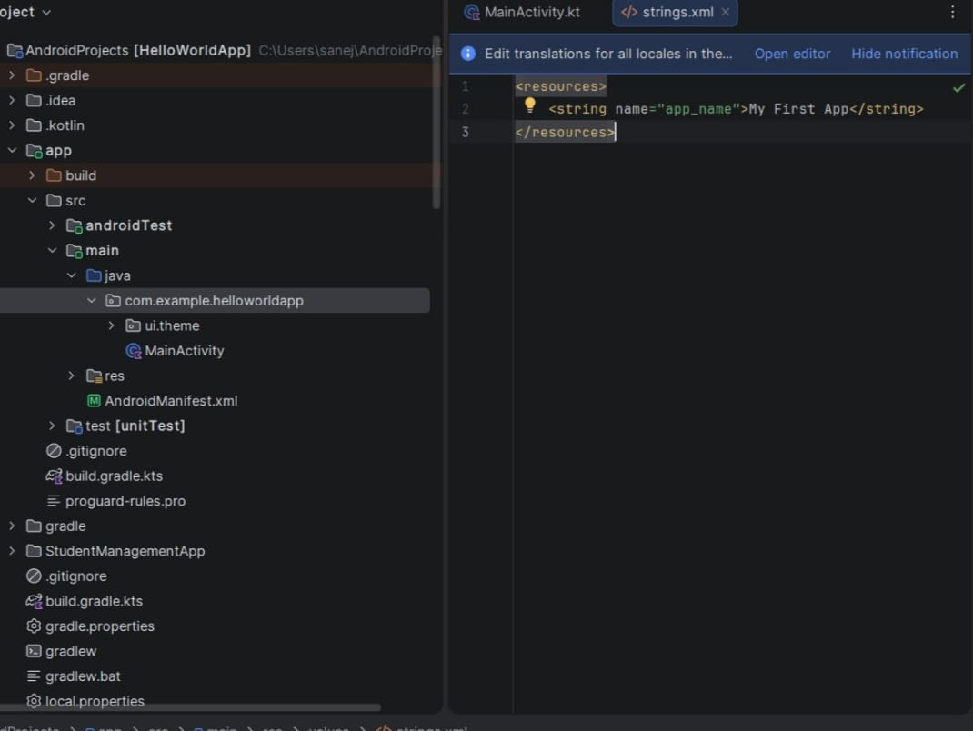

Tools/Software Used
Flutter

Personal Reflection
I learned to install flutter ‘set up an android emulator,and create a basic hello world app. beginning was pure chaos ,emulator crushed and was slow ,I read the entire error message before searching on google and also decided to test on a real physical phone .SDK path errors not compatible with Expo go but USB debugging was the best plus also learned how simple to create an app .
Week 2: Mobile Development Environment
Login Page screenshot
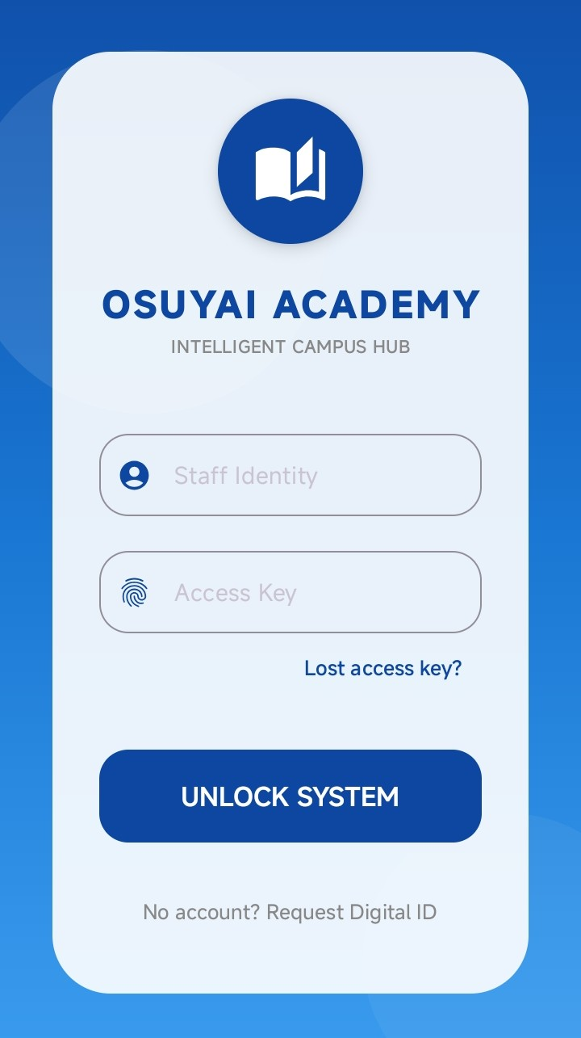

2:Dashboard screenshot 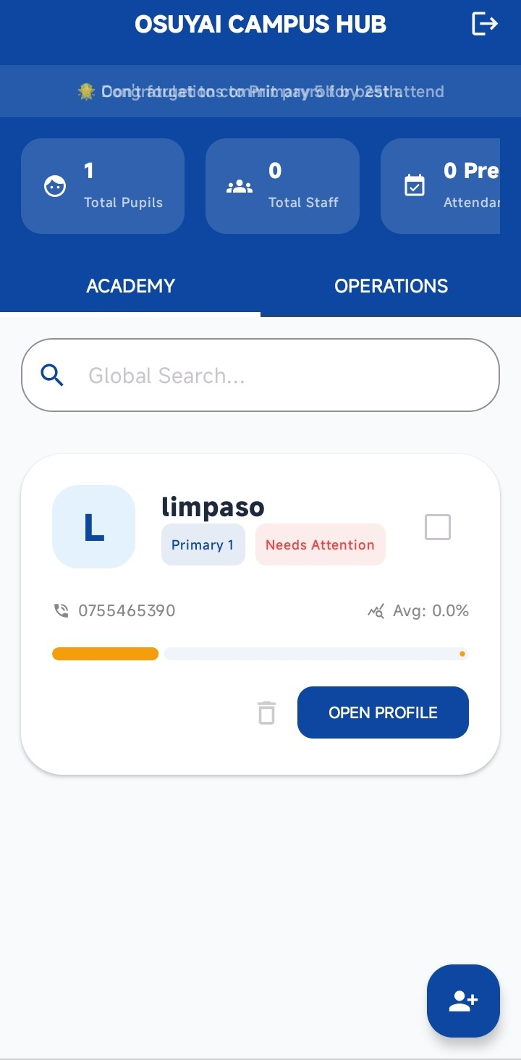

- Registration Screenshot

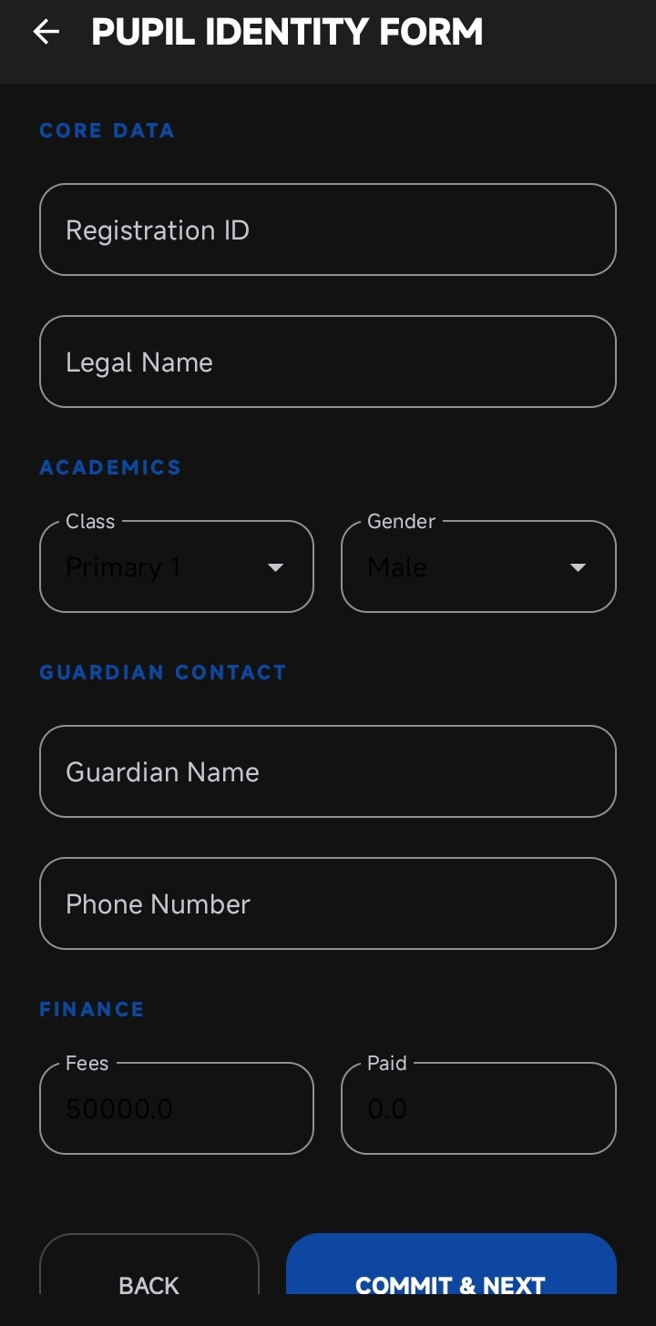
4:Student management source code
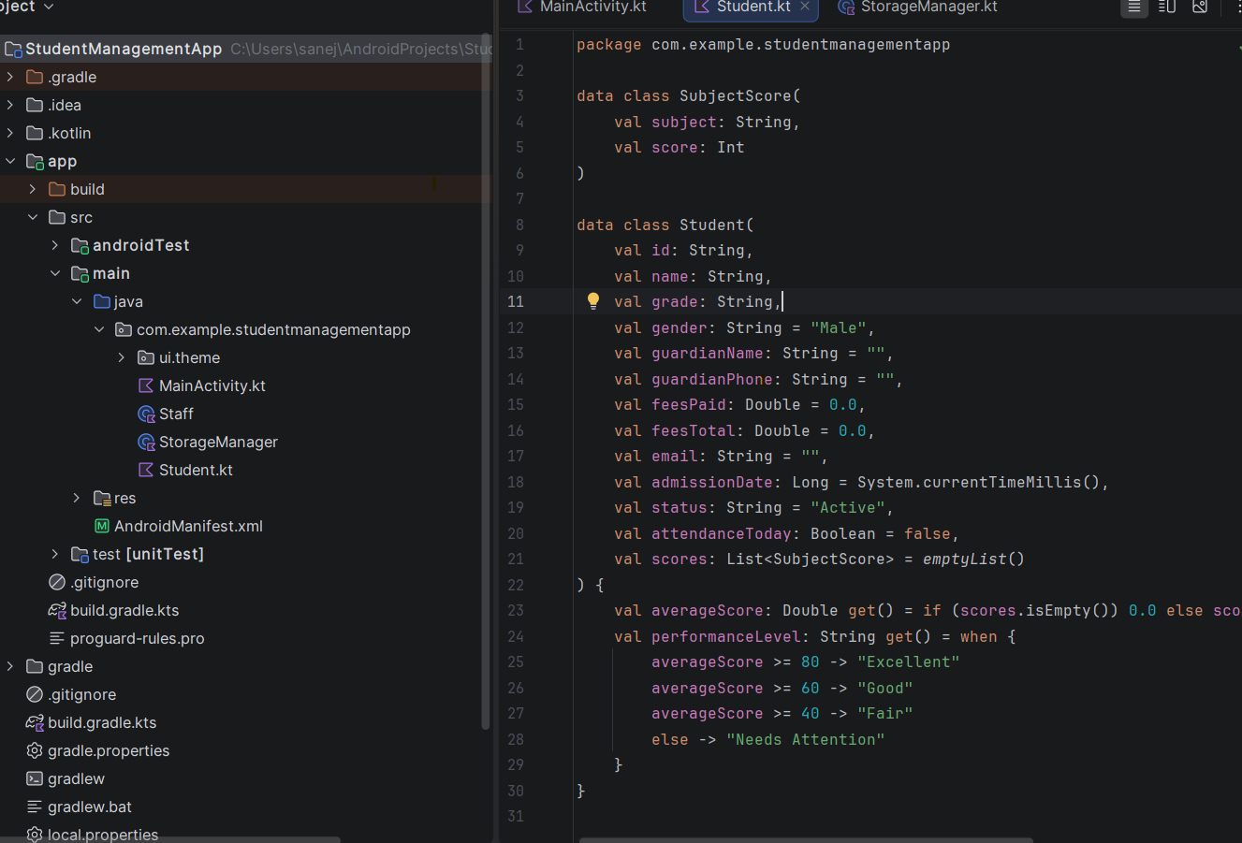

Tools/Software Used
Flutter , Dart , Android studio
Personal Reflection
Creating the mini student management app was a good experience. I successfully implemented key features such as create ,add and delete students records which helped me understand how data is managed within an application. Based on user interface design skills I can now design a simple app. I also learned the importance of testing features to ensure they work correctly. I encountered several challenges. Setting up the development environment and understanding project structure took time.

Week 3: User Interface Design
SCREENSHOTS
  - LOGIN PAGE
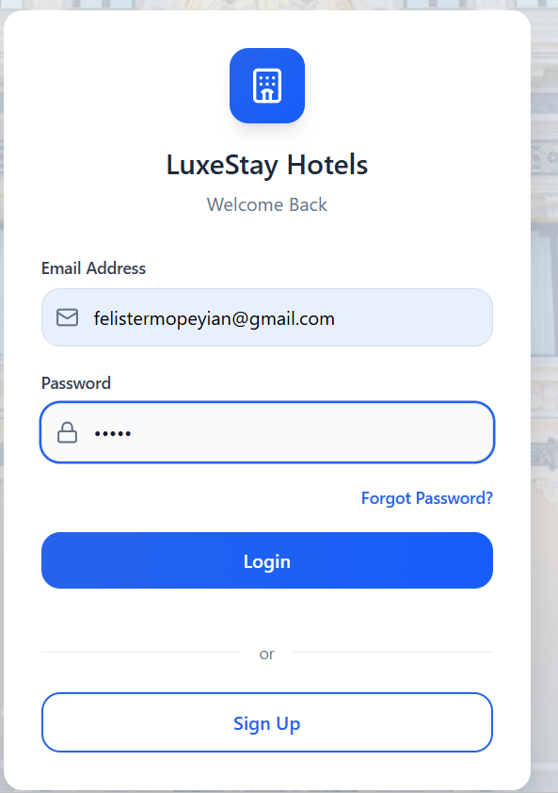

1:2DASHBOARD
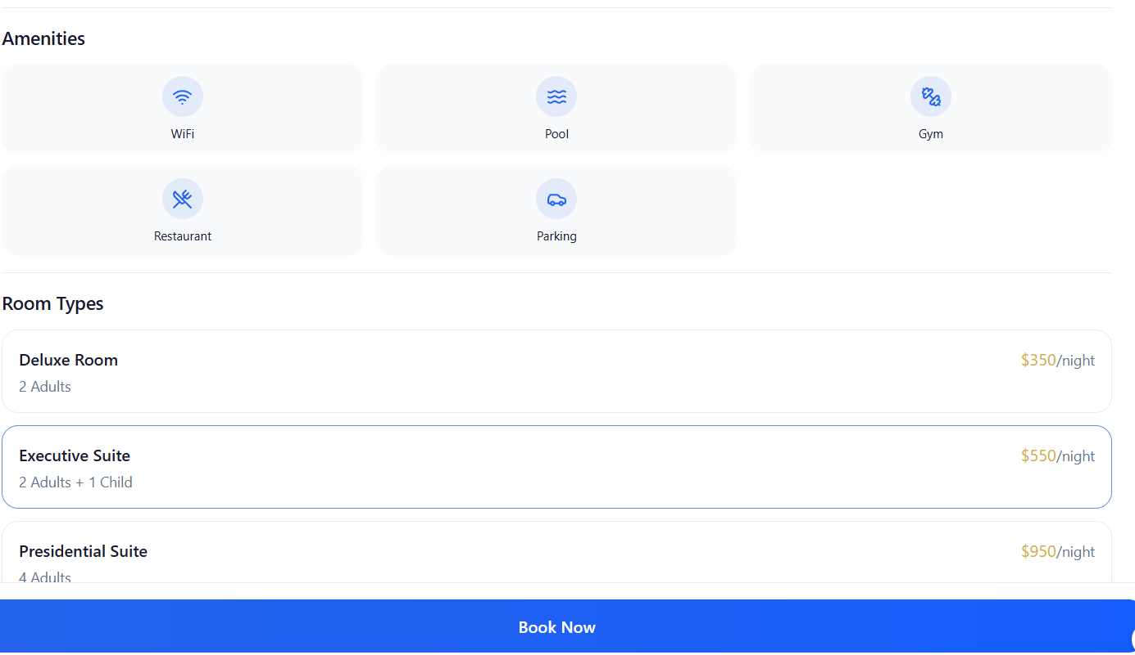

1:3
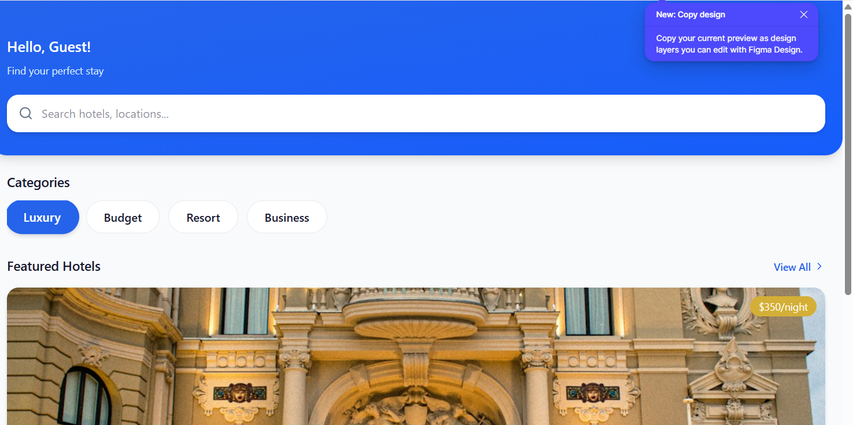
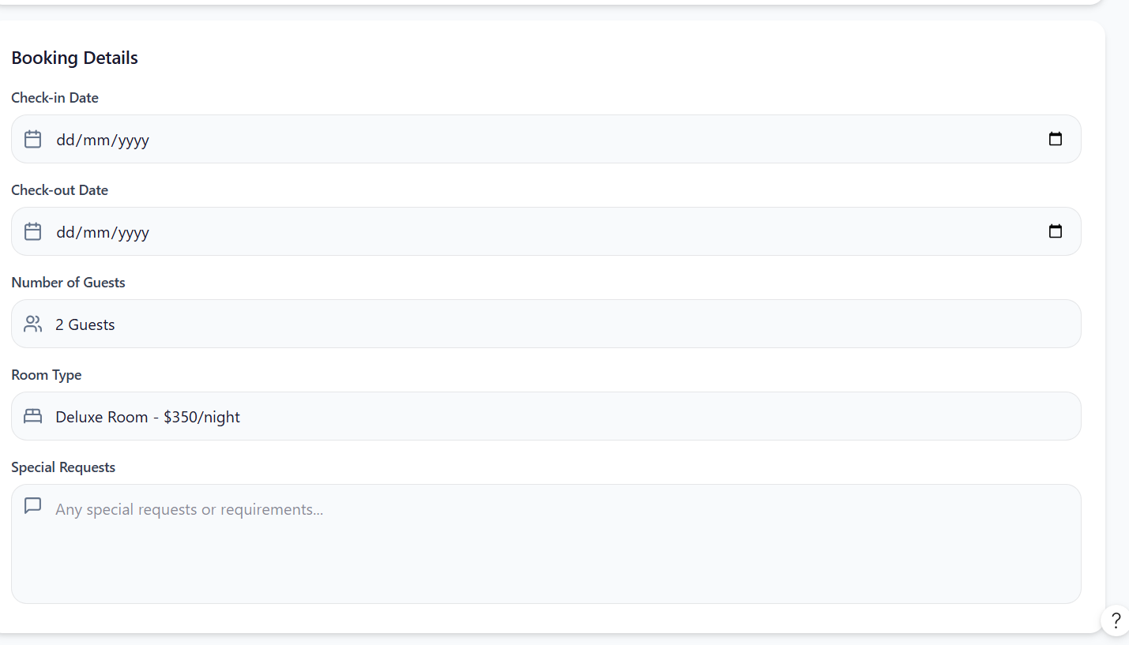

Tools/Software Used
I used figma in developing the prototype of luxestay hotel it was a bit simple and easy to understand .

DOCUMENTATION

1. Hello World App

Objective
To create a simple Android application that displays "Hello World".

Tools Used
- Android Studio
- Kotlin

Outcome

I learned how to create, run, and test a basic Android application.

2. Mini Student Management App

Objective
To develop an app for managing student records.

Features
- Login page
- Add student records
- View student records
- Delete student records

Outcome
I learned how to create forms, manage data, and navigate between screens.

Challenges
- Fixing coding errors
- Implementing add and delete functions
- Testing the application

3. Figma Prototype

Objective

To design the app interface before development.

Screens Designed
- Welcome Screen
- Login Screen
- Student Registration Screen
- Student Records Screen

Outcome
I learned basic UI/UX design and how to plan an application before coding.

Conclusion
These projects helped me gain practical skills in mobile app development, interface design, problem-solving, and application testing.

